Title of a Manuscript for the XXIII RiNEm

A. Author⁽¹⁾, B. Author⁽²⁾

- Department of Electrical and Electronic Engineering, University of Cagliari
Piazza D’Armi, 09123 Cagliari, Italy
email@unica.it

Abstract
This file is a template for Microsoft Word. It gives you guidelines for preparing papers for the XXIII RiNEm. The official language of the meeting is Italian, but manuscripts should be written in English. This allows a wider audience to get up to date on Italian recent research advances in Electromagnetics. The Abstract should clearly summarize the paper aim in 100-150 words.
Index Terms − About four key words or phrases in alphabetical order, separated by commas.

- Introduction

The paper is divided in Sections. The first Section is an introduction. In the last Section the conclusions are given. Appendices and acknowledgements may follow. At the end of the paper, references are listed.

- Figures

In Fig. 1 you can see a figure. Please save your graphs with a good resolution in order to obtain high-quality figures. Labels, legends, and other characters inside the figure, should be clearly legible. Place figure captions below the figures. If your figure has two parts, use the labels “(a)” and “(b)” to identify them.
Please verify that the figures you mention in the text actually exist. Use the abbreviation “Fig.” inside a sentence to mention a figure.

- Tables

In Table I you can see a table. Tables are numbered with Roman numerals. Note that no vertical lines are present in a table.
Use the word “Table” (without abbreviation) inside a sentence to mention a table. Please verify that the figures you mention in the text actually exist.

- References

Number citations consecutively in square brackets [1]. Multiple references [2], [3] are each numbered with separate brackets [1]–[3]. In sentences, refer simply to the reference number, as for example [3]; do not use “Ref. [3]” or “reference [3]” except at the beginning of a sentence: “Reference [3] shows ... .”
Type the reference list at the end of the paper using the “References” style.

- Equations

Number equations consecutively with equation numbers in parentheses flush with the right margin, as in Eq. (1). Use the equation editor to create the equation.

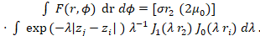 (1)

Be sure that the symbols in your equation have been defined before the equation appears or immediately following. Italicize symbols (for example, T might refer to temperature, but T is the unit tesla). Refer to “Eq. (1)” except at the beginning of a sentence: “Equation (1) is ... .”
Please, verify that all your equations have the same size!

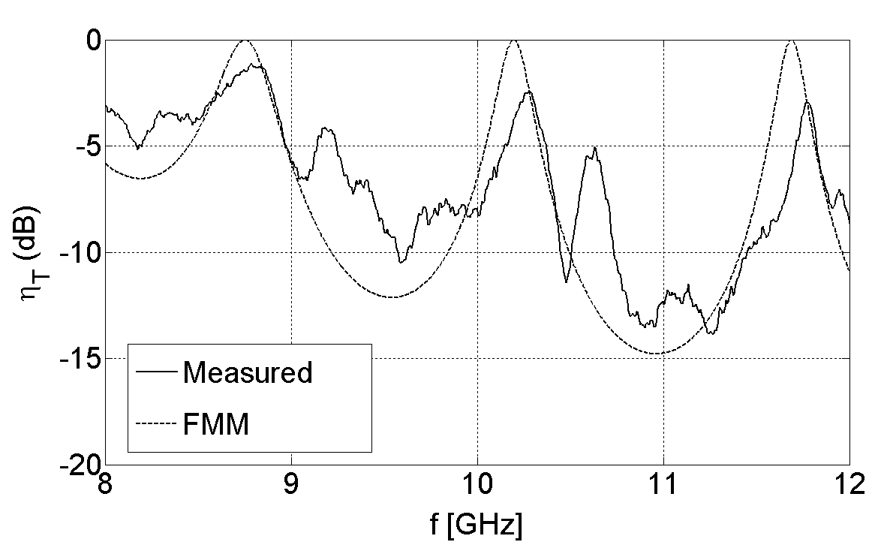

Fig. 1 − Transmission efficiency (in dB) as a function of frequency (in GHz). It is good practice to explain the significance of the figure in the caption.

Table I - Units for Magnetic Properties

Symbol | Quantity | Conversion from Gaussian and  CGS EMU to SI ª
Φ | magnetic flux | 1 Mx → 10⁻⁸ Wb = 10⁻⁸ V·s
B | magnetic flux density,  magnetic induction | 1 G → 10⁻⁴ T = 10⁻⁴ Wb/m²
H | magnetic field strength | 1 Oe → 10³/(4π) A/m
m | magnetic moment | 1 erg/G = 1 emu  → 10⁻³ A·m² = 10⁻³ J/T
M | magnetization | 1 erg/(G·cm³) = 1 emu/cm³  → 10³ A/m
μ | permeability | 1 → 4π × 10⁻⁷ H/m  = 4π × 10⁻⁷ Wb/(A·m)
μ_{r} | relative permeability | μ → μ_{r}
N, D | demagnetizing factor | 1 → 1/(4π)

- Conclusion

A conclusion section is required. Although a conclusion may review the main points of the paper, do not replicate the abstract as the conclusion. A conclusion might elaborate on the importance of the work or suggest applications and extensions.

Appendix

Appendixes, if needed, appear before the acknowledgment.

Acknowledgement

Use the singular heading even if you have many acknowledgments.

References

[1] L. Pajewski and G. Schettini, “Filtering and transmission properties of electromagnetic band-gap structures with periodicity interruptions,” New Frontiers in Radiation and Guidance Phenomena: a Tribute to Arthur A. Oliner, ed. by F. Frezza and P. Lampariello, Borgia, Roma, 2007, pp. 209-216.

[2] P. Burghignoli, L. Pajewski, F. Frezza, A. Galli, and G. Schettini, “Improved quadrature formulas for boundary integral equations with conducting or dielectric edge singularities,” IEEE Transactions on Antennas and Propagation, vol. 52(2), pp. 373-379, Feb. 2004.

[3] F. Frezza, L. Pajewski, C. Ponti, and G. Schettini, “Electromagnetic Scattering by Underground Targets Using the Cylindrical-Wave Approach,” Geophysical Research Abstracts, vol. 12, EGU2010-9829, European Geosciences Union (EGU) General Assembly 2010, May 2-7 2010, Wien, Austria, 2pp.

[4] L. Pajewski, “Scattering di onde elettromagnetiche da strutture composite,” Ph. D. in Applied Electromagnetics and Electrophysics Sciences, “La Sapienza” University of Rome, June 2004.

